Promises Detailed

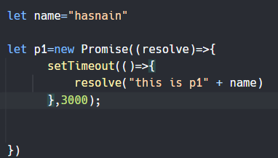

Promise ke bahir se bhi variables le sakty hain, meaning ke ager hum promise ka ek parent function bna dein tu bss uss funciton ke parameters mein he as an argument hamein main se variables pick krna hoga

Example below

